
Face Identification Task Instructions
User hand: R
ID #: Even

The goal of this task is to identify the gender presentation of a target face as quickly as possible and ignore the distractor stimuli. The task consists of 4 blocks of 56 trials and should take approximately 15 minutes to complete.

Task protocol

After a 5 second countdown, a white fixation cross will appear in the centre of the screen. Please focus on this cross for the duration of the task. Each block will start with the countdown.

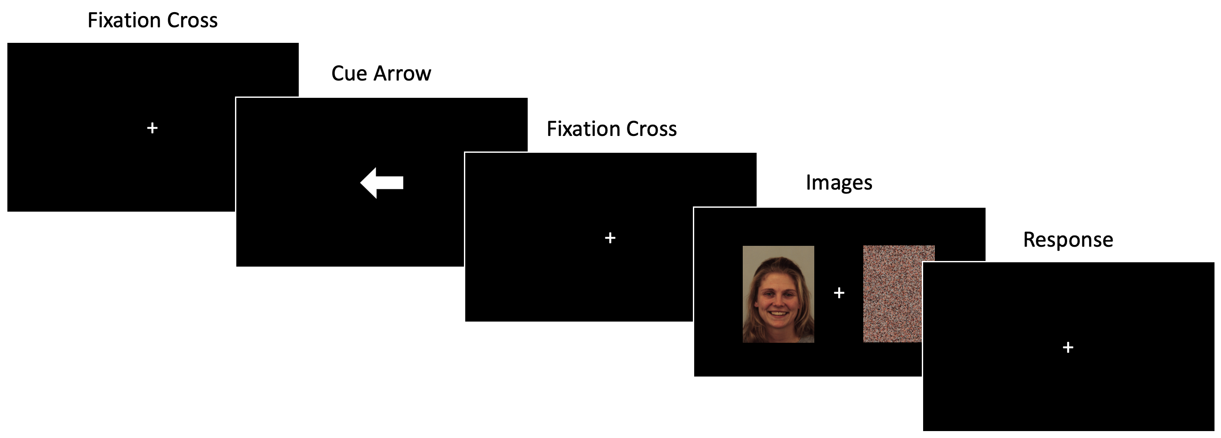
After a short time period, an arrow will appear in the centre of the screen and point to the upcoming location of a target face. The fixation cross will appear in the centre once again and then two images will be very briefly shown either side of the fixation cross; the target face and distractor image (which may also be a face). Keep your eyes on the fixation cross in the centre of the screen whilst the images are shown, i.e., only use your periphery vision to look at the target face. See below for an example trial:

Your task is to report the gender presentation of the target face (in the cued location, as shown by the arrow), as quickly as possible and ignore the other face or shape on the other side of the cross. For the purposes of this task please consider gender as binary, i.e., male or female. If the target face presents as male, press the ‘P’ keyboard key; if the target face presents as female, press the ‘L’ keyboard key.

Reminder: Focus on the fixation cross in the centre of the screen during the entire task

Try to be as quick and accurate as possible. There is no feedback during the task.

There are 4 blocks in total; each block contains 56 trials.

If you have any questions, please ask the experimenter now

Face Identification Task Instructions
User hand: R
ID #: Odd

The goal of this task is to identify the gender presentation of a target face as quickly as possible and ignore the distractor stimuli. The task consists of 4 blocks of 56 trials and should take approximately 15 minutes to complete.

Task protocol

After a 5 second countdown, a white fixation cross will appear in the centre of the screen. Please focus on this cross for the duration of the task. Each block will start with the countdown.


After a short time period, an arrow will appear in the centre of the screen and point to the upcoming location of a target face. The fixation cross will appear in the centre once again and then two images will be very briefly shown either side of the fixation cross; the target face and distractor image (which may also be a face). Keep your eyes on the fixation cross in the centre of the screen whilst the images are shown, i.e., only use your periphery vision to look at the target face. See below for an example trial:

Your task is to report the gender presentation of the target face (in the cued location, as shown by the arrow), as quickly as possible and ignore the other face or shape on the other side of the cross. For the purposes of this task please consider gender as binary, i.e., male or female. If the target face presents as male, press the ‘L’ keyboard key; if the target face presents as female, press the ‘P’ keyboard key.

Reminder: Focus on the fixation cross in the centre of the screen during the entire task

Try to be as quick and accurate as possible. There is no feedback during the task.

There are 4 blocks in total; each block contains 56 trials.

If you have any questions, please ask the experimenter now

Face Identification Task Instructions
User hand: L
ID #: Even

The goal of this task is to identify the gender presentation of a target face as quickly as possible and ignore the distractor stimuli. The task consists of 4 blocks of 56 trials and should take approximately 15 minutes to complete.

Task protocol

After a 5 second countdown, a white fixation cross will appear in the centre of the screen. Please focus on this cross for the duration of the task. Each block will start with the countdown.


After a short time period, an arrow will appear in the centre of the screen and point to the upcoming location of a target face. The fixation cross will appear in the centre once again and then two images will be very briefly shown either side of the fixation cross; the target face and distractor image (which may also be a face). Keep your eyes on the fixation cross in the centre of the screen whilst the images are shown, i.e., only use your periphery vision to look at the target face. See below for an example trial:

Your task is to report the gender presentation of the target face (in the cued location, as shown by the arrow), as quickly as possible and ignore the other face or shape on the other side of the cross. For the purposes of this task please consider gender as binary, i.e., male or female. If the target face presents as male, press the ‘A’ keyboard key; if the target face presents as female, press the ‘Z’ keyboard key.

Reminder: Focus on the fixation cross in the centre of the screen during the entire task

Try to be as quick and accurate as possible. There is no feedback during the task.

There are 4 blocks in total; each block contains 56 trials.

If you have any questions, please ask the experimenter now

Face Identification Task Instructions
User hand: L
ID #: Odd

The goal of this task is to identify the gender presentation of a target face as quickly as possible and ignore the distractor stimuli. The task consists of 4 blocks of 56 trials and should take approximately 15 minutes to complete.

Task protocol

After a 5 second countdown, a white fixation cross will appear in the centre of the screen. Please focus on this cross for the duration of the task. Each block will start with the countdown.


After a short time period, an arrow will appear in the centre of the screen and point to the upcoming location of a target face. The fixation cross will appear in the centre once again and then two images will be very briefly shown either side of the fixation cross; the target face and distractor image (which may also be a face). Keep your eyes on the fixation cross in the centre of the screen whilst the images are shown, i.e., only use your periphery vision to look at the target face. See below for an example trial:

Your task is to report the gender presentation of the target face (in the cued location, as shown by the arrow), as quickly as possible and ignore the other face or shape on the other side of the cross. For the purposes of this task please consider gender as binary, i.e., male or female. If the target face presents as male, press the ‘Z’ keyboard key; if the target face presents as female, press the ‘A’ keyboard key.

Reminder: Focus on the fixation cross in the centre of the screen during the entire task

Try to be as quick and accurate as possible. There is no feedback during the task.

There are 4 blocks in total; each block contains 56 trials.

If you have any questions, please ask the experimenter now

